Example 1: Math, output
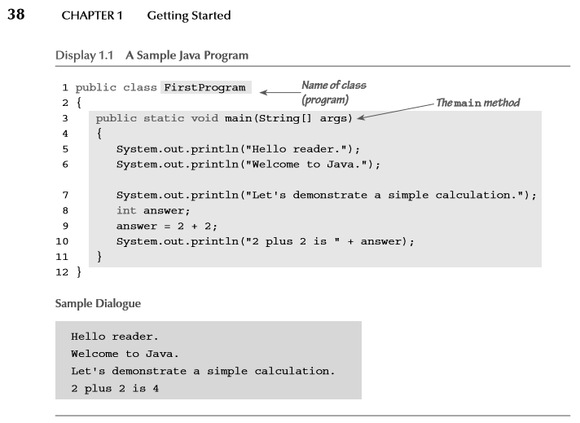

$$3+\frac{3×-6}{3}+\left(3×15\right)= ??$$

Change line 10 to say: “The answer to life the universe and everything = ??“

Java Documentation - http://docs.oracle.com/javase/8/docs/
*** Java SE API Documentation ***

Example 2: Basic Input and Output
- Look up the Scanner class in the Java API documentation
- Write a short program in main() of some class that prompts the user for some input, gets that input, and then echoes the input onto the screen.
  - use standard I/O (System.out.println() and Scanner class -> Chapter 2 of Savitch text)

import java.util.Scanner;
Scanner scan = new Scanner(System.in);
scan.nextLine(); //returns a String
scan.nextInt(); //returns an Int

